Supplementary Information for

**Predicting predator search rates from metabolic rates: a bottom-up modelling approach.**

Flavio Affinito1, Miguel Matias2, Samraat Pawar1 and Rebecca L. Kordas1

*1. Department of Life Sciences, Imperial College London, Silwood Park Buckhurst Road, SL5 7PY, Ascot UK*

*2. Museo Nacional de Ciencias Naturales (CSIC), Madrid, 28006, Spain*

**Corresponding author:** *E-mail: flavio.affinito@gmail.com*

Figure S1. The Iberian Ponds network is located in the thermally diverse Iberian Peninsula.

EXPERIMENTS

Feeding trials

**Table S1** Length-weight regression equations, where *L* stands for length.

MODELLING

Velocity estimation

Search rate model derivation

Dimensionality effect

Biological rates and temperature-dependence

**Table S2.** Sharpe-Schoolfield model choice.

**Table S3.** Sharpe-Schoolfield model parameter estimates and fit.

**Figure S2.** Yearly recorded temperatures at each site.

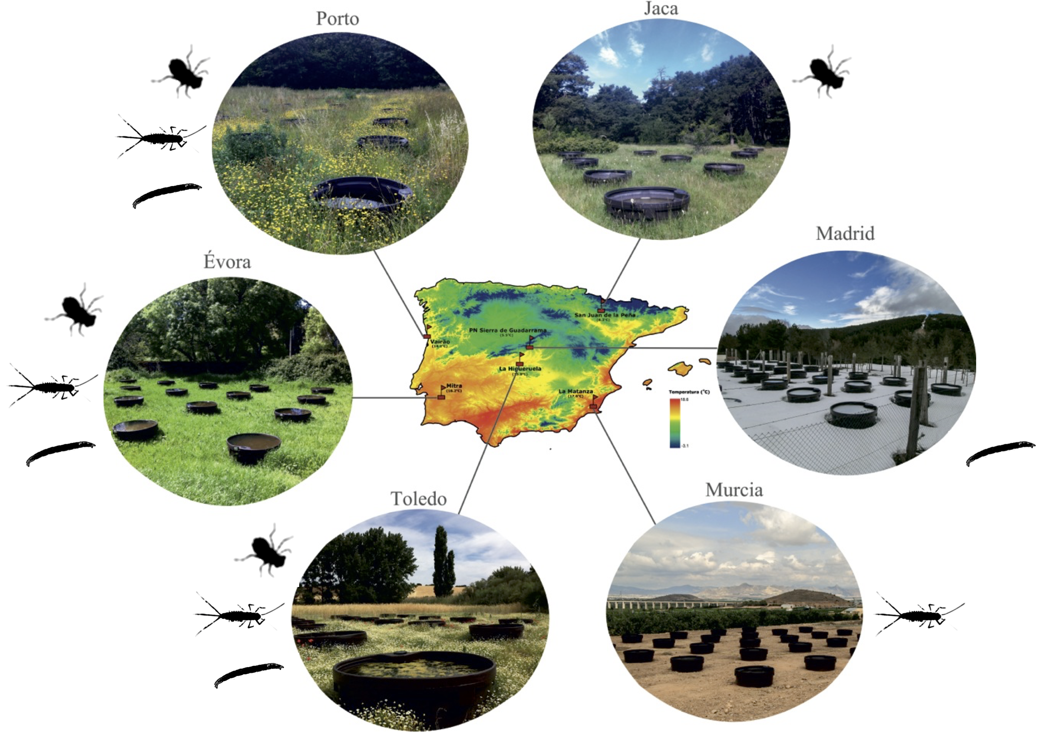

Figure S1. **The Iberian Ponds network is located in the thermally diverse Iberian Peninsula.** The location of all six mesocosm experimental sites is shown with respect to a thermal map of the peninsula. Individual taxa sampled at each site are displayed (Jaca: *S. striolatum* alone; Madrid: *Chironomus* spp. alone; Murcia: *C. cloeon* alone). Coordinates for the sites are: Peñalara: ,; Jaca: 42.506643, -0.668493; Porto: ,; Toledo: ,; Evora: ,; Murcia: ,.

# EXPERIMENTS

## Feeding trials

To determine predator-prey relationships between species, we conducted feeding trials at each site. For each potential predator-prey pair, we placed one individual of a predator species into a water filled jar (50 ml), then added 2 individuals of a potential prey species. Individuals were left in jars overnight and the number of prey individuals was counted in the morning. These trials revealed a predatory relationship between the dragonfly species *Sympetrum striolatum* and two prey taxa, the mayfly species *Cloeon dipterum* and the chironomid genus *Chironomus*. Some taxa were not found in high enough abundance at some sites to use in respirometry experiments due to differences in larval phenology (Fig S1).

Table S1 Length-weight regression equations, where *L* stands for length. Individuals were measured under the microscope and placed in an individual foil cup. *Odonata* and *Ephemeroptera* individuals were measured from the tip of the abdomen to the midpoint between the eyes and all antennae were ignored. *Chironomidae* individuals were measured from the mouth to the base of the terminal prolegs. All cups were labelled and left in an oven at 80°C for 16 to 18 hours to dry completely. Dry-weights were then recorded for each individual. *Odonata* and *Ephemeroptera* linear models yielded satisfactory fit (*R2* > 0.6), *Chironomidae* was taken from the literature.

|  |  |  |  |  |  |
| --- | --- | --- | --- | --- | --- |
| Taxa | Regression | R2 |  | N | Reference |
| *Odonata* | $$W=-0.63.{10}^{-3}+0.22.{10}^{-3}L$$ | 0.88 |  | 49 |  |
| *Ephemeroptera* | $$W=e^{-10.12+0.41L}$$ | 0.65 |  | 104 |  |
| *Chironomidae* | $$W={0.6.{10}^{-3}L}^{2.77}$$ | 0.86 |  |  | Benke *et al.*, 1999 |

# MODELLING

## Velocity estimation

The taxa used in this study are swimmers. The energetics of swimming have been studied for various species (Videler and Nolet, 1990; Videler, 1993; Alexander, 2003). Assuming velocity scales linearly with metabolic rate (Tucker, 1970), we can convert a measure of oxygen consumption (*B*; equation 1) into one of velocity. The relationship between respiration and velocity is linked to a measure of the cost of transport (*C*): the amount of energy in J needed to transport 1N over 1min submerged swimmers (Videler, 1993). Thus, we express velocity as:

|  |  |  |
| --- | --- | --- |
|  | $$v=\frac{B_{j}}{Cmg}$$ | (S1) |

Where *Bj* is oxygen consumption converted in J.s-1, *C* is in J.N-1.m-1, *m* is mean mass in kg and *g* is gravitational acceleration in m.s-2. Cost of transport in swimmers scales with body mass as follows (Videler and Nolet, 1990):

|  |  |  |
| --- | --- | --- |
|  | $$C=1.1m^{-0.038}$$ | (S2) |

Oxygen consumption for nutrient combustion is the primary means by which nutrients are converted into energy. Oxygen consumption, measured in μmol.h-1 can be converted to g.h-1 by multiplying by the atomic mass of O2: 31.988g/mol. The combustion of carbohydrates, fat and protein yields 3.34cal per 1mg of oxygen (Elliott and Davison, 1975) and 1cal yields 4.2868J (Merrill and Watt, 1973; Food and Agriculture Organization, 2015). Thus, we estimate the energetic output of respiration by defining a conversion coefficient of oxygen combustion:

|  |  |  |
| --- | --- | --- |
|  | $$γ=M_{O_{2}}KE_{k}$$ | (S3) |

Where *MO2* is the atomic mass of oxygen, *K* is the caloric value of oxygen combustion and *Ek* is the energetic value of a calorie. We can express velocity’s temperature dependence with respect to metabolism as:

|  |  |  |
| --- | --- | --- |
|  | $$v=\frac{\left(\frac{b_{0}m^{β}e^{\frac{-E_{a}}{k}\left(\frac{1}{T}-\frac{1}{T_{ref}}\right)}}{1+ e^{\frac{E_{d}}{k}\left(\frac{1}{T_{pk}}-\frac{1}{T}\right)}}\right)γ}{1.1m^{0.962}g}$$ | (S4) |

## Search rate model derivation

### Dimensionality effect

The dimensionality component *D* for equation 4 expands into (Pawar, Dell and Savage, 2012):

|  |  |  |
| --- | --- | --- |
|  | $$D=d^{\left(D_{m}-1\right)}s_{D}$$ | (S5) |

Species interactions in nature can be defined as either 2D (*Dm*=2; *sD*=2) or 3D (*Dm*=3; *sD*=π) dependent on the environment they interact in (Pawar, Dell and Savage, 2012). In this component, *d* is the detection distance of a predator and is dependent upon the respective body masses of the predator-prey pair:

|  |  |  |
| --- | --- | --- |
|  | $$d= d_{0}{\left(m_{r}m_{c}\right)}^{p_{d}}$$ | (S6) |

Where *d0*  is the minimum detection distance, *mr* and *mc* are prey and predator mass respectively and *pd* is the empirical scaling exponent of dimensionality(Pawar, Dell and Savage, 2012). Thus, when considering the effect of dimensionality on search rates, we obtain two scenarios:

|  |  |  |
| --- | --- | --- |
|  | $$2D:D=2d_{0}{\left(m_{r}m_{c}\right)}^{p_{d}}$$ | (S7) |
|  | $$3D:D= π{\left(d_{0}{\left(m_{r}m_{c}\right)}^{p_{d}}\right)}^{2}$$ | (S8) |

### Biological rates and temperature-dependence

Relative body velocity is expressed as (Dell, Pawar and Savage, 2011, 2014):

|  |  |  |
| --- | --- | --- |
|  | $$v_{r}=\sqrt{{v_{r}}^{2}+{v_{c}}^{2}}$$ | (S9) |

Where *vr* and *vc* are prey and predator body velocities respectively. Here, we consider two interaction cases, one where prey species are relatively sessile compared to the predator ($v_{r}≈v_{c}$) and one where both predator and prey are in active movement and equation S4 holds true. Predator and prey velocities as a biological rates scale with temperature and mass:

|  |  |  |
| --- | --- | --- |
|  | $$v_{c,r}=b_{0_{c,r}}{m_{c,r}}^{β_{c,r}}e^{\frac{{-E}_{c,r}}{k}\left(\frac{1}{T}-\frac{1}{T_{ref}}\right)}$$ | (S10) |

Where c and *r* subscripts apply to predator and prey respectively, *bO* is the baseline trait performance at a reference temperature (*Tref*), *m* is mass, *β* is the mass scaling exponent, *E* is activation energy and *T* is temperature. Hence when the prey is considered sessile we get:

|  |  |  |
| --- | --- | --- |
|  | $$2D:a=b_{0_{c}}{m_{c}}^{β_{c}}e^{\frac{{-E}_{c}}{k}\left(\frac{1}{T}-\frac{1}{T_{ref}}\right)}2d_{0}{\left(m_{r}m_{c}\right)}^{p_{d}}$$ | (S11) |
|  | $$3D:a=b_{0_{c}}{m_{c}}^{β_{c}}e^{\frac{{-E}_{c}}{k}\left(\frac{1}{T}-\frac{1}{T_{ref}}\right)}π{\left(d_{0}{\left(m_{r}m_{c}\right)}^{p_{d}}\right)}^{2}$$ | (S12) |

When both predator and prey species are active we have:

|  |  |  |
| --- | --- | --- |
|  | $$v_{r}=\sqrt{{b_{0_{r}}}^{2}{m_{r}}^{{2β}_{r}}e^{\frac{{-2E}_{r}}{k}\left(\frac{1}{T}-\frac{1}{T_{ref}}\right)}+{{{b_{0_{c}}}^{2}m}_{c}}^{{2β}_{c}}e^{\frac{{-2E}_{c}}{k}\left(\frac{1}{T}-\frac{1}{T_{ref}}\right)}}$$ | (S13) |

Hence:

|  |  |  |
| --- | --- | --- |
|  | $$v_{r}= b_{0_{c}}{m_{c}}^{β_{c}}e^{\frac{{-E}_{c}}{k}\left(\frac{1}{T}-\frac{1}{T_{ref}}\right)}+\sqrt{1+{\left(\frac{b_{0_{r}}}{b_{0_{c}}}\right)}^{2}{\left(\frac{{m_{r}}^{β_{r}}}{{m_{c}}^{β_{c}}}\right)}^{2}e^{\frac{2}{k}\left(\frac{1}{T}-\frac{1}{T_{ref}}\right)\left(E_{c}-E_{r}\right)}}$$ | (S14) |

Thus, for active predator-prey search rate models we have:

|  |  |  |
| --- | --- | --- |
|  | $$2D: a=\left[b_{0_{c}}{m_{c}}^{β_{c}}e^{\frac{{-E}_{c}}{k}\left(\frac{1}{T}-\frac{1}{T_{ref}}\right)}+\sqrt{1+{\left(\frac{b_{0_{r}}}{b_{0_{c}}}\right)}^{2}{\left(\frac{{m_{r}}^{β_{r}}}{{m_{c}}^{β_{c}}}\right)}^{2}e^{\frac{2}{k}\left(\frac{1}{T}-\frac{1}{T_{ref}}\right)\left(E_{c}-E_{r}\right)}}\right].2d_{0}{\left(m_{r}m_{c}\right)}^{p_{d}}$$ | (S15) |
|  | $$3D:a=\left[b_{0_{c}}{m_{c}}^{β_{c}}e^{\frac{{-E}_{c}}{k}\left(\frac{1}{T}-\frac{1}{T_{ref}}\right)}+\sqrt{1+{\left(\frac{b_{0_{r}}}{b_{0_{c}}}\right)}^{2}{\left(\frac{{m_{r}}^{β_{r}}}{{m_{c}}^{β_{c}}}\right)}^{2}e^{\frac{2}{k}\left(\frac{1}{T}-\frac{1}{T_{ref}}\right)\left(E_{c}-E_{r}\right)}}\right].π{\left(d_{0}{\left(m_{r}m_{c}\right)}^{p_{d}}\right)}^{2}$$ | (S16) |

Table S2 Sharpe-Schoolfield model choice. Three Sharpe-Sharpe-Schoolfield models were run with different mass scalings for the normalisation constant *b0* (; equation 1). One model where mass scaling was ignored (*β* = 0), one where *b0* scaled with mass according to the metabolic theory of ecology (*β* = 0.75; (Brown *et al.*, 2004)) and one where mass scaling was left free and *β* was estimated from the data along with all other parameters of the model. For each species at each site, 10,000 iterations of each model type were run, the best fit model was selected based on the overall mean fit (*R2*), AIC and BIC values of all runs.

|  |  |  |  |  |  |
| --- | --- | --- | --- | --- | --- |
| Taxa | Mass Scaling | Site | Mean AIC | Mean BIC | Mean R2 |
| *Chironomus* spp. | 0 | Peñalara | -220 | -207 | 0.46 |
| *Chironomus* spp. | 0 | Porto | -192 | -178 | 0.27 |
| *Chironomus* spp. | 0 | Toledo | -109 | -96.0 | 0.11 |
| *Chironomus* spp. | 0 | Evora | -387 | -372 | 0.26 |
| *C. dipterum* | 0 | Porto | -12.0 | 1.00 | 0.60 |
| *C. dipterum* | 0 | Toledo | 25.0 | 37.0 | 0.71 |
| *C. dipterum* | 0 | Evora | 91.0 | 105 | 0.48 |
| *C. dipterum* | 0 | Murcia | 2.00 | 12.0 | 0.46 |
| *S. striolatum* | 0 | Jaca | 12.0 | 25.0 | 0.01 |
| *S. striolatum* | 0 | Porto | 152 | 165 | 0.27 |
| *S. striolatum* | 0 | Toledo | -29.0 | -18.0 | 0.21 |
| *S. striolatum* | 0 | Evora | 300 | 314 | 0.36 |
| *Chironomus* spp. | 0.75 | Peñalara | -73.0 | -60.0 | 0.36 |
| *Chironomus* spp. | 0.75 | Porto | -38.0 | -25.0 | 0.33 |
| *Chironomus* spp. | 0.75 | Toledo | 14.0 | 28.0 | 0.18 |
| *Chironomus* spp. | 0.75 | Evora | -207 | -192 | 0.46 |
| *C. dipterum* | 0.75 | Porto | 33.0 | 47.0 | 0.63 |
| *C. dipterum* | 0.75 | Toledo | 11.0 | 23.0 | 0.80 |
| *C. dipterum* | 0.75 | Evora | 190 | 203 | 0.35 |
| *C. dipterum* | 0.75 | Murcia | 60.0 | 70.0 | 0.58 |
| *S. striolatum* | 0.75 | Jaca | -7.00 | 6.00 | 0.35 |
| *S. striolatum* | 0.75 | Porto | 117 | 130 | 0.34 |
| *S. striolatum* | 0.75 | Toledo | 23.0 | 35.0 | 0.42 |
| *S. striolatum* | 0.75 | Evora | 104 | 117 | 0.57 |
| *Chironomus* spp. | Free | Peñalara | -208 | -192 | 0.40 |
| *Chironomus* spp. | Free | Porto | -226 | -210 | 0.46 |
| *Chironomus* spp. | Free | Toledo | -129 | -112 | 0.27 |
| *Chironomus* spp. | Free | Evora | -468 | -449 | 0.53 |
| *C. dipterum* | Free | Porto | -15.0 | 1.00 | 0.62 |
| *C. dipterum* | Free | Toledo | 18.0 | 33.0 | 0.74 |
| *C. dipterum* | Free | Evora | 80.0 | 96.0 | 0.53 |
| *C. dipterum* | Free | Murcia | -2.00 | 9.00 | 0.57 |
| *S. striolatum* | Free | Jaca | 3.00 | 19.0 | 0.11 |
| *S. striolatum* | Free | Porto | 151 | 166 | 0.29 |
| *S. striolatum* | Free | Toledo | -20.0 | -7.00 | 0.13 |
| *S. striolatum* | Free | Evora | 291 | 307 | 0.42 |

Table S3 Sharpe-Schoolfield model parameter estimates and fit. All TPC parameters (*Ea*: activation energy, *Ed*: deactivation energy, *b0*: normalisation constant, *β*: mass scaling parameter, *Tpk*: temperature of peak performance) were chosen from the best-fit model after 10000 non-linear least squares model runs. Only taxa where enough individuals were collected to run the experiments are represented as not all species were not found in sufficient numbers at each site (Fig S1). All parameter values are shown ± standard error.

|  |  |  |  |  |  |  |  |  |
| --- | --- | --- | --- | --- | --- | --- | --- | --- |
| Taxa | Site | *Ea* | *Ed* | *b0* | *β* | *Tpk* | R2 | N |
| *Chironomus* spp. | Peñalara | 0.91±0.09 | 29.47±216.104 | 0.01±0.56.10-2 | 0.80±0.54 | 43.41±1.94 | 0.64 | 99.0 |
| *Chironomus* spp. | Porto | 0.61±0.04 | 27.89±977.103 | 0.07±0.18.10-1 | 0.91±0.26 | 43.50±4.12 | 0.70 | 110 |
| *Chironomus* spp. | Toledo | 0.53±0.08 | 28.08±153.104 | 0.18±0.06 | 1.38±0.26 | 43.36±1.72 | 0.52 | 108 |
| *Chironomus* spp. | Evora | 0.60±0.04 | 29.78±278.104 | 0.08±0.05 | 0.94±0.52 | 43.49±1.11 | 0.64 | 164 |
| *C. dipterum* | Porto | 0.97±0.16 | 1.34±0.33 | 0.07±0.01 | -0.74±0.37 | 40.00±4.49 | 0.62 | 102 |
| *C. dipterum* | Toledo | 1.59±0.17 | 2.17±0.34 | 0.03±0.60.10-2 | 0.22±0.33 | 36.87±1.50 | 0.77 | 86.0 |
| *C. dipterum* | Evora | 0.67±0.06 | 4.18±1.50 | 0.20±0.03 | 0.62±0.30 | 39.00±1.54 | 0.62 | 109 |
| *C. dipterum* | Murcia | 0.89±0.13 | 2.77±2.10 | 0.13±0.03 | 0.72±0.36 | 39.71±1.84 | 0.62 | 52.0 |
| *S. striolatum* | Jaca | 0.90±0.08 | 3.24±0.55 | 0.05±0.67.10-2 | 0.75±0.00 | 35.66±1.06 | 0.55 | 101 |
| *S. striolatum* | Porto | 0.81±0.07 | 5.16±1.09 | 0.10±0.01 | 0.75±0.00 | 38.30±1.02 | 0.53 | 94.0 |
| *S. striolatum* | Toledo | 0.77±0.10 | 3.22±1.13 | 0.10±0.02 | 0.75±0.00 | 38.93±1.26 | 0.60 | 75.0 |
| *S. striolatum* | Evora | 0.77±0.07 | 2.88±0.38 | 0.27±0.02 | 0.75±0.00 | 34.71±0.95 | 0.64 | 111 |



Figure S2 Yearly recorded temperatures at each site. Temperatures recorded by loggers over 2-3 years plotted per month. Site mean temperature added in red.